Lab Number: 3
Title: Windows Batch Script Automation for Local and Remote Repository Synchronization using Git

Objective: To automate the synchronization of local and remote repositories using a Windows Batch Script

Programming Language: Windows Batch Script

IDE/Platform: Notepad and Windows PowerShell (with Windows Task Scheduler)

Theory:
- A Windows Batch Script is a plain text file with a .bat extension that contains a series of commands executed automatically by the Windows Command Processor (cmd.exe). It is widely used to automate repetitive administrative tasks such as copying files, creating backups, and synchronizing folders, reducing the need for manual command execution.

- The xcopy command is used to copy files along with entire directory structures. The command @echo off is typically placed at the beginning of a batch script to hide command execution from the console, producing cleaner output. Frequently used switches include /I (assumes the destination is a directory), /E (copies all subdirectories, including empty ones), and /Y (suppresses overwrite confirmation prompts).

- Windows Task Scheduler enables scripts and programs to run automatically based on predefined schedules rather than requiring manual execution. A scheduled task consists of a trigger (such as a daily schedule or specific time interval) and an action (such as executing a batch file). By configuring a recurring trigger, file synchronization or other maintenance tasks can run continuously in the background without user intervention.

- Git is a distributed version control system that tracks changes to files and enables collaboration between a local repository on a user's computer and a remote repository hosted on a server. A local repository is initialized using git init, and changes follow a three-stage workflow: the working directory, the staging area (using git add), and the commit history (created with git commit).

- Remote repository synchronization allows local commits to be shared with a remote repository. After linking the remote repository using git remote add origin <url>, changes are uploaded with git push. Useful commands such as git status, git log, and git remote -v provide information about the repository's current state, commit history, and configured remote connections, making it easier to monitor and manage version control operations.

Implementation:

Perform Windows Batch Script Automation for Local and Remote Repository Synchronization using Git

Algorithm:
- Local repository replication automation procedure:
• Create a source folder (source7) and a destination folder (dest7) inside the working directory.
- Put a sample file inside the source folder to act as the data that needs replicating.
- Open Notepad and write a batch script that uses the xcopy command with the /I, /E, and /Y switches to copy all files and subfolders from the source folder into the destination folder.
- Save the script with a .bat extension, naming it Replication.bat.
- Run the script manually once and confirm the sample file has been copied over into the destination folder.
- Open Windows Task Scheduler and set up a new Basic Task named "ReplicateIt".
- Set the trigger to run the task daily at a chosen start time.
- Set the action to launch the Replication.bat program.
- Go into the trigger's advanced settings, set it to repeat every 5 minutes indefinitely, and enable the task.
- Add a new file to the source folder and wait for the scheduled trigger to fire.
- Check the destination folder to confirm the new file was automatically replicated, which confirms local synchronization has been successfully automated.

1. Remote Repository Synchronization Procedure (Git):
- Open Windows PowerShell and move into the working directory that contains Replication.bat.
- Set up a new local Git repository with git init.
- Run git status to check the repository's status and view the untracked files.
- Stage the batch script for commit using git add Replication.bat.
- Commit the staged changes with a descriptive message using git commit -m "Add Replication Batch Script".
- Link the local repository to a remote one using git remote add origin <repositoryurl>.
- Rename the default branch to main with git branch -M main.
- Push the committed changes up to the remote repository using git push origin main.
- Confirm the synchronization locally by running git status, git log --oneline, and git remote -v.
- Check the remote repository's web interface to confirm the batch script and commit history have synced successfully.

Block Diagram:
- Local Replication Automation Flow:
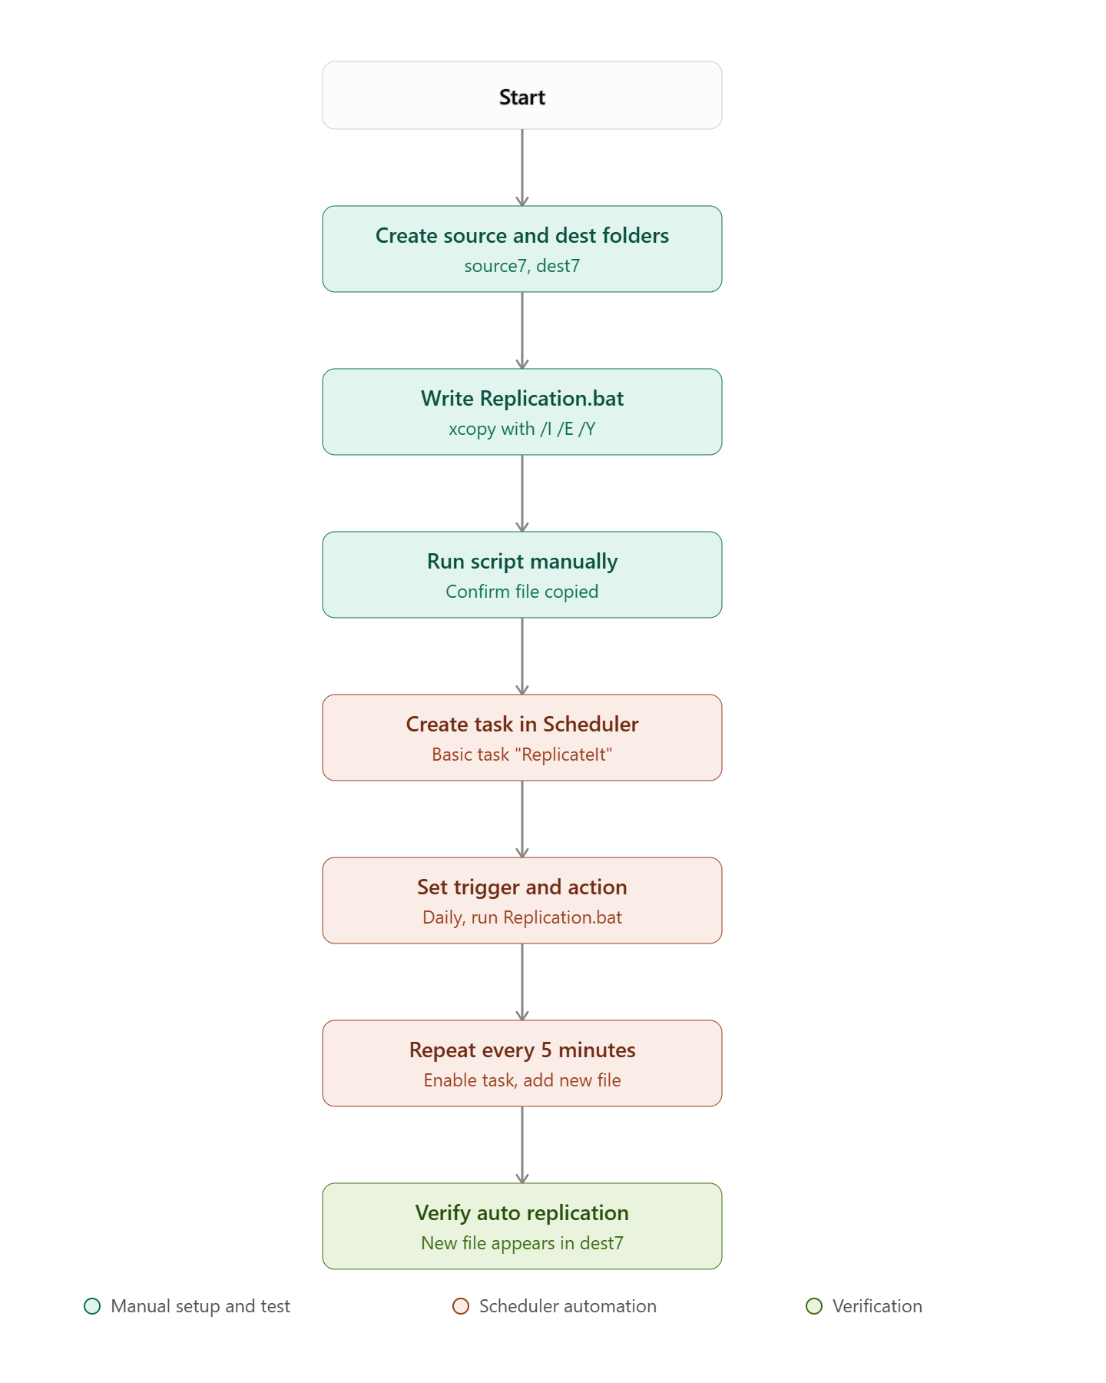

- Remote Git Synchronization Flow:

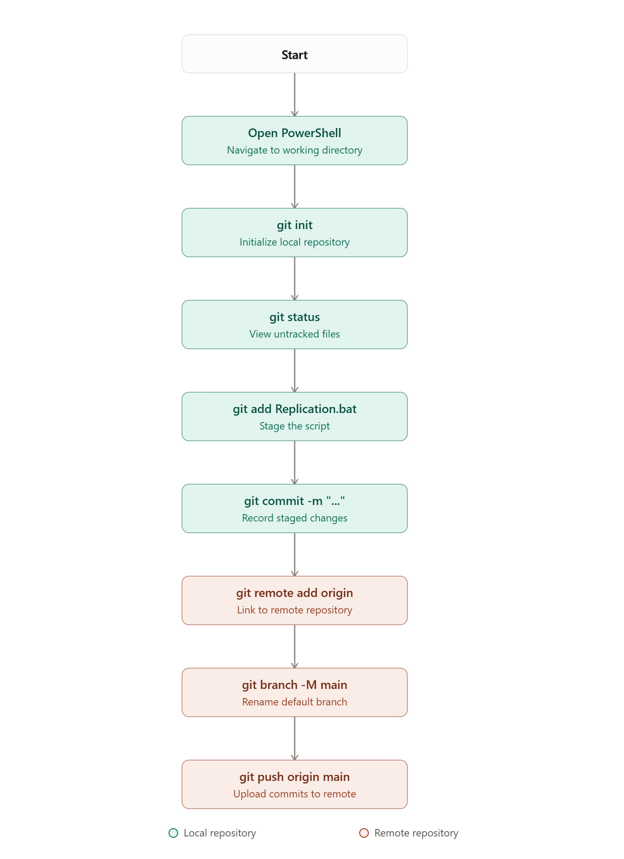

Source Code:
- Replication.bat (Local Replication Script):
@echo off xcopy
C:\Siddhant_Shrestha_024bscit040\Source
C:\Siddhant_Shrestha_024bscit040\Destination /I/E/Y
echo Done.

- PowerShell Commands (Remote Git Synchronization Flow):
cd C:\Siddhant_Shrestha_024bscit040
git init
git add.
git add Replica.bat
git commit -m "Initialize"
git remote add origin https://agentrepo.com/playground/Siddhant
git push origin master
git clone https://agentrepo.com/playground/Siddhant git pull origin master

Output Section:
- Source and Destination folder
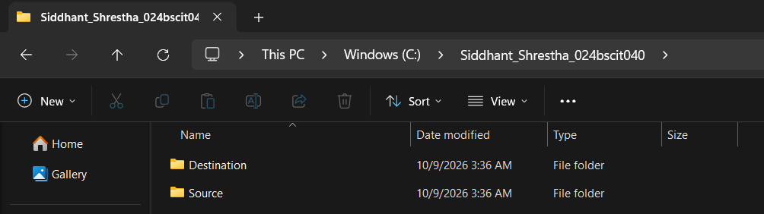

- Creating files and folders in Source
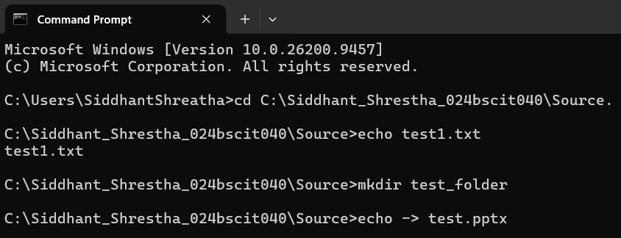

- Test (.txt) file
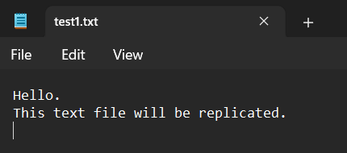

- replica.bat code in Notepad
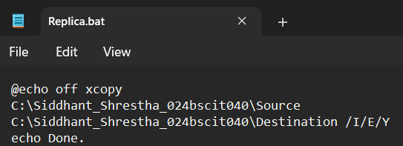

- In Task Scheduler:
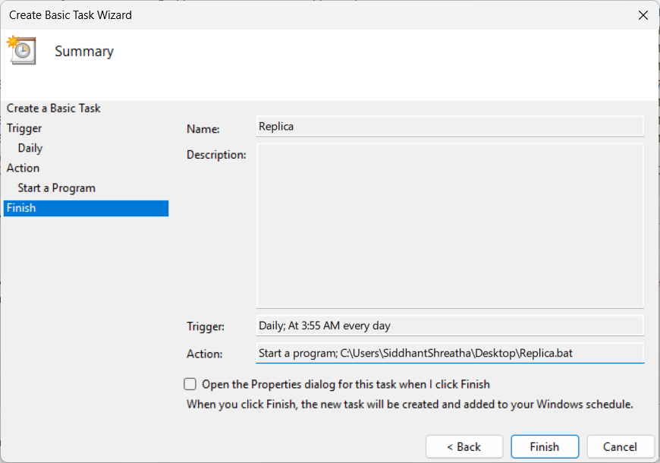

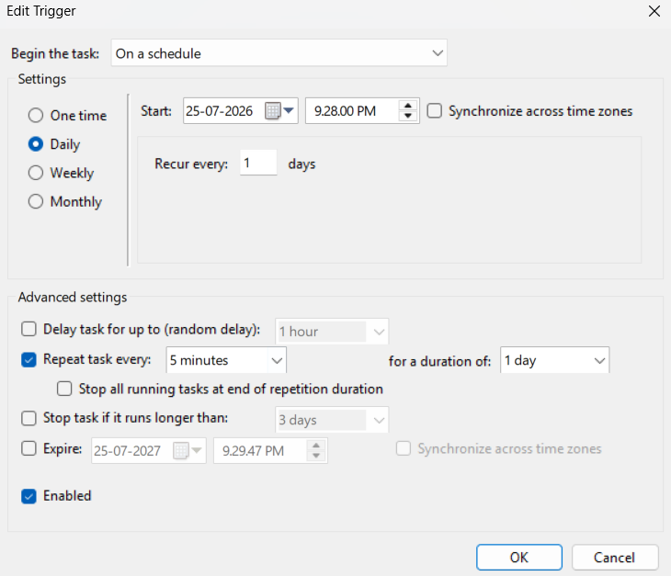

- After 5 mins
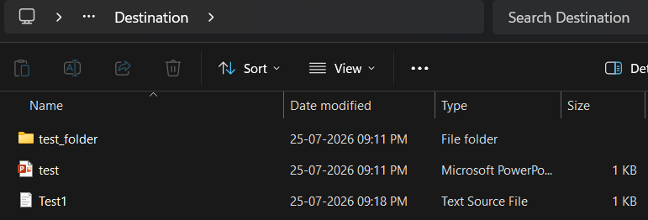

- git add, git commit and git push
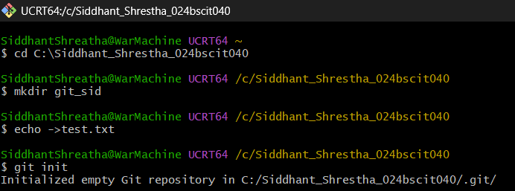
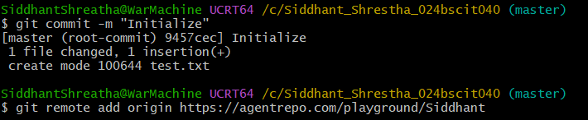
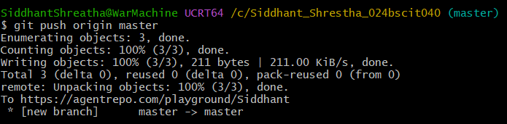

- git pull
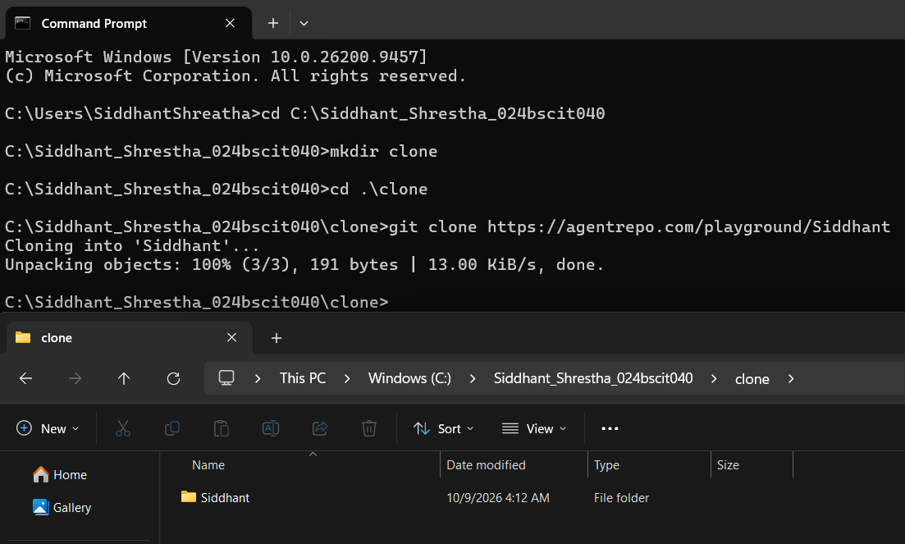

Discussion:
For the local replication automation, the xcopy command was used inside Replication.bat with the /I, /E, and /Y switches to copy files and subfolders from source7 to dest7 without needing manual confirmation. Windows Task Scheduler was then set up with a daily trigger and a 5-minute repeat interval, so any new file added to source7 got automatically replicated to dest7 without having to run the script by hand again.
For the remote synchronization part, the batch script was brought under Git version control by initializing a repository with git init, then staging and committing the file, and linking it to a remote using git remote add origin. After that, git push origin main uploaded the commit history, and git status, git log --oneline, and git remote -v were used to confirm that the local and remote repositories were correctly in sync.

Conclusion:
Hence, local file replication was successfully automated using Windows Batch Scripting and Task Scheduler, and the batch script was synchronized with a remote Git repository using PowerShell and Git.

